Name: Neel Shah

Class: CSE-AI SY B

PRN: 22311420

Roll no.: 282044

**Assignment 3**

# Problem Statement

Visualize the data using R/Python by plotting the graphs for assignment no. 1 and 2. Consider suitable data set. Use Scatter plot, Bar plot, Box plot, Pie chart, Line Chart.

# Objective

The objective of this assignment is to visualize datasets using various types of plots such as scatter plot, bar plot, box plot, pie chart, and line chart. These plots help us better understand the distribution, relationships, and trends within the data.

# Resources Used

Programming Language: Python Libraries Used:

pandas - for data handling matplotlib - for plotting graphs seaborn - for advanced visualizations

Datasets: heart.csv (heart disease dataset)

# Introduction to Visualization

Data visualization is the graphical representation of information and data. By using visual elements like charts, graphs, and maps, data visualization tools make it easier to understand patterns, trends, and outliers in data.

# Methodology

## Load Dataset

Used pandas to import the dataset from CSV or Excel files

Verified and explored the dataset

## Scatter Plot

Plotted to show the relationship between two numerical variables

Example: Age vs Fare in Titanic dataset

## Bar Plot

Used to compare quantities across categories

Example: Survival count grouped by gender in Titanic dataset

## Box Plot

Used to display distribution and detect outliers

Example: Fare distribution in Titanic dataset

## Pie Chart

Shows proportional data

Example: Percentage of passengers in each class

## Line Chart

Used for time series or ordered data

Example: Trend in fare values sorted by index

# Advantages

Makes complex data easy to understand

Helps identify patterns and trends quickly

Useful for comparing different groups visually

Enhances interpretation and decision making

# Disadvantages

Can be misleading if not properly scaled or labeled

Requires appropriate chart selection for accurate representation

Overuse of visuals can clutter the analysis

# Real Life Applications

1. Business: Sales and marketing data trends over months
2. Healthcare: Patient record visualizations for diagnosis
3. Finance: Stock market data visualizations over time
4. Education: Student performance analysis using bar and line charts
5. Social Media: Visualization of engagement metrics and trends

# Screenshots of Program Outputs

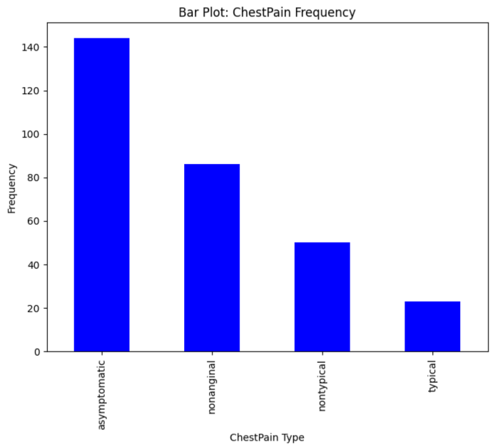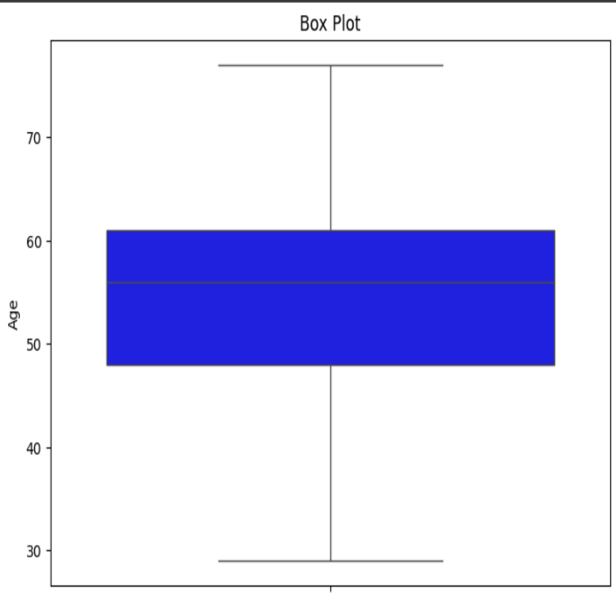

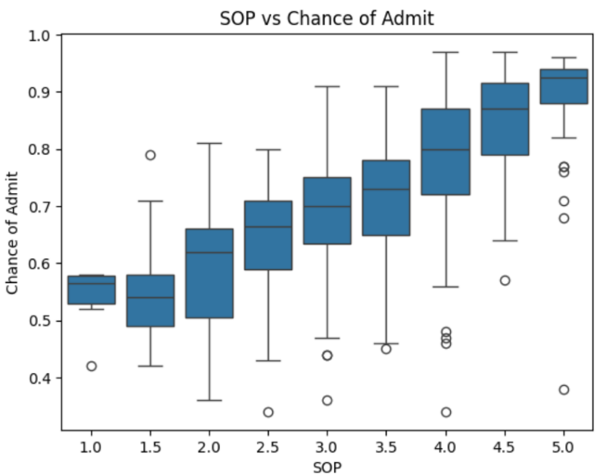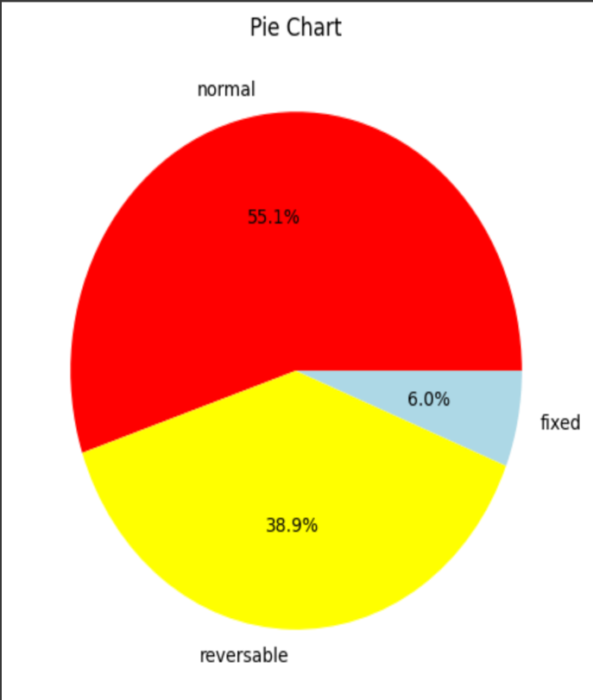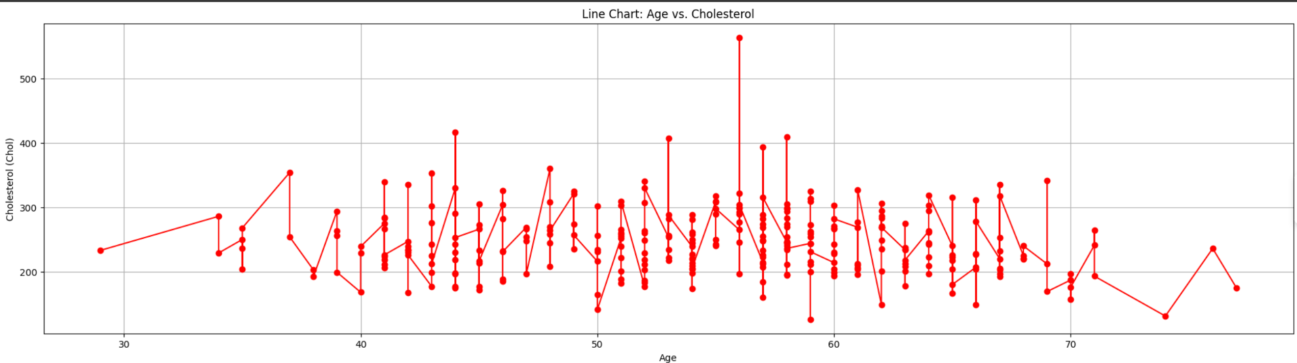

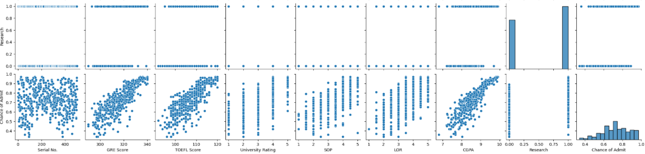**Conclusion**

Visualization plays a crucial role in data analysis. It helps in making sense of the data and uncovering hidden insights. By using different types of plots, we can draw meaningful interpretations that aid in better decision-making. In this assignment, we practiced using multiple chart types to represent various aspects of the dataset, enriching our data understanding and analytical skills.